DC motor Control
Motor gives power to your MCU. Ya power to do physical works, for example move your robot. So it is essential to know how to control a DC motor effectively with a MCU. We can control a DC motor easily with microcontrollers. We can start it, stop it or make it go either in clockwise or anti clock wise direction.

DC Motor (Intermediate and Advance users can skip this)
A DC motor is electromechanical device that converts electrical energy into mechanical energy that can be used to do many useful works. It can produce mechanical movement like moving the tray of CD/DVD drive in and out (you may like to try it out Go to My Computer, right click the drive icon and click "Eject"). This shows how software controls a motor. DC motors comes in various ratings like 6V and 12V. It has two wires or pins. When connected with power supply the shaft rotates. You can reverse the direction of rotation by reversing the polarity of input.

Control with MCUs
As the MCUs PORT are not powerful enough to drive DC motors directly so we need some kind of drivers. A very easy and safe is to use popular L293D chips. It is a 16 PIN chip. The pin configuration is as follows.
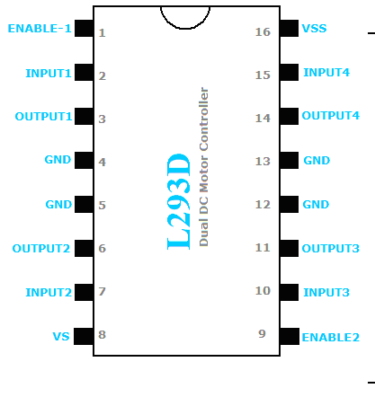

L293D Dual DC Motor Controller.
This chip is designed to control 2 DC motors. There are 2 INPUT and 2 OUTPUT PINs for each motors. The connections is as follows.
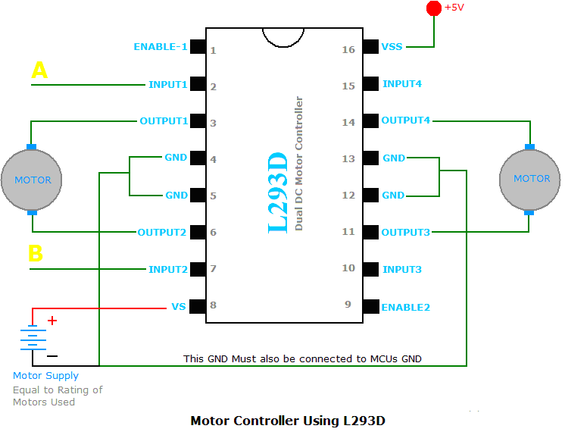

Fig: Motor Controller Using L293d chip.
The behavior of motor for various input conditions are as follows
 | A | B
Stop | Low | Low
Clockwise | Low | High
Anticlockwise | High | Low
Stop | High | High
So you saw you just need to set appropriate levels at two PINs of the microcontroller to control the motor. Since this chip controls two DC motors there are two more output pins (output3 and output4) and two more input pins(input3 and input4). The INPUT3 and INPUT4 controls second motor in the same way as listed above for input A and B. There are also two ENABLE pins they must be high(+5v) for operation, if they are pulled low(GND) motors will stop.The following program starts the motor runs it one direction for some time and then reverses the direction.

#include <avr/io.h>
#include <util/delay.h>

void Wait()
{
char i;
for (i=0;i<100;i++)
_delay_loop_2(0);
}

void main()
{
//Setup port D pin 4,5 as output.
DDRD=(1<<PD4)|(1<<PD5);

while(1)
{
//Clock wise
PORTD=0B00010000;
Wait();

//Anti clock wise
PORTD=0B00100000;
Wait();

//Stop
PORTD=0;
Wait();
}
}

